Q1.
Answer is B and C.

A: Global average, not per department.
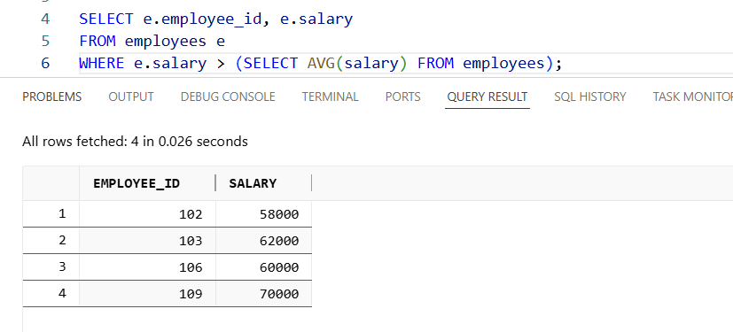

B: Correct. Subquery by department.
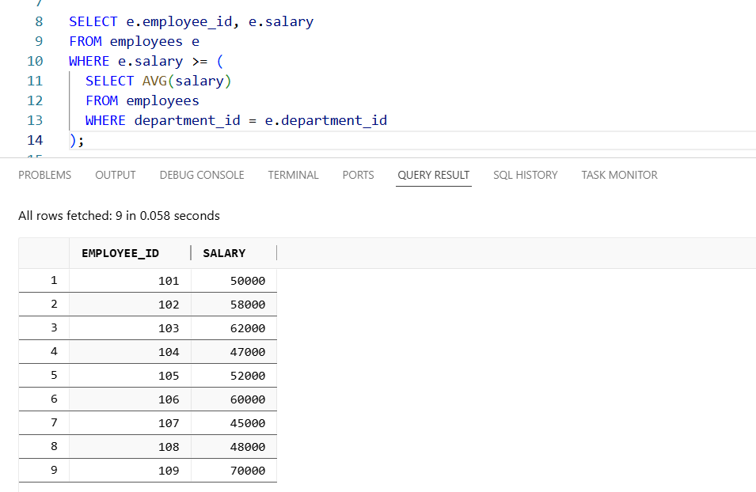

C: Also correct but more complex.
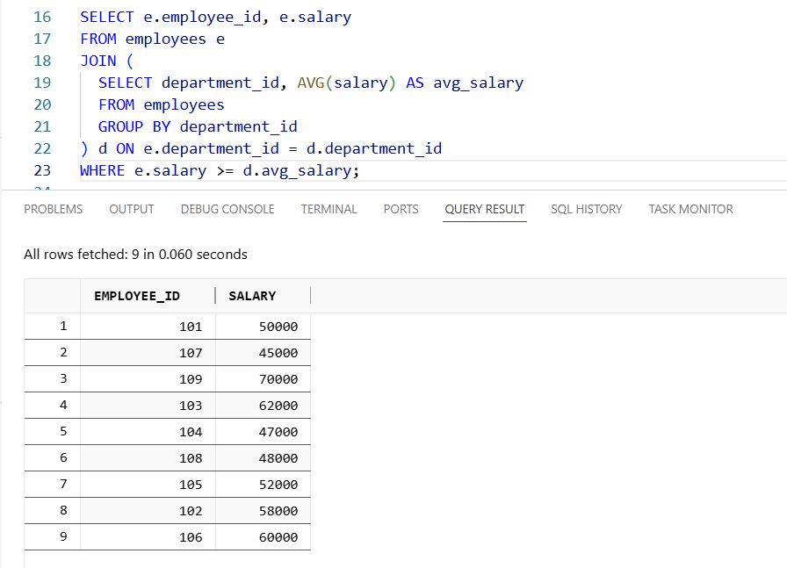

D: Misuse of aggregation in WHERE.
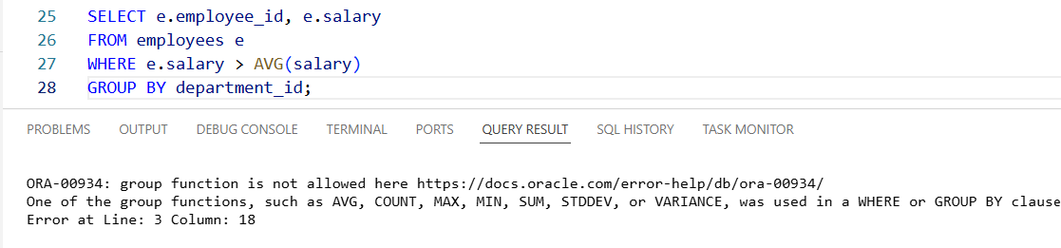

Q2.
Answer is C.

A: It is false. Here the subquery is in the SELECT cluase, not the WHERE.
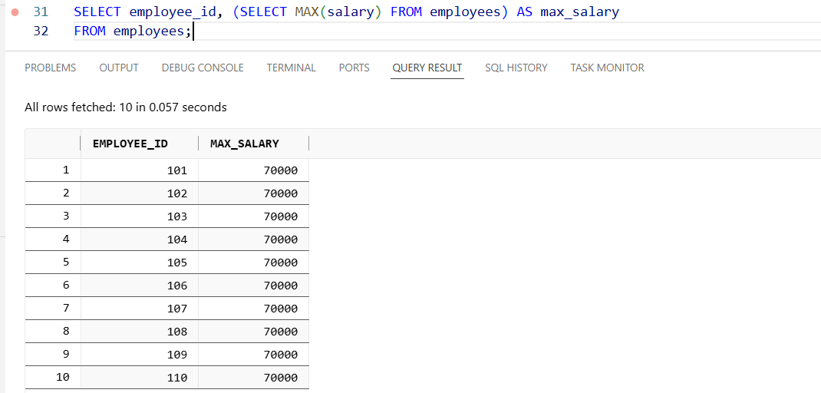

B: This is false. Here the subquery returns a single value.
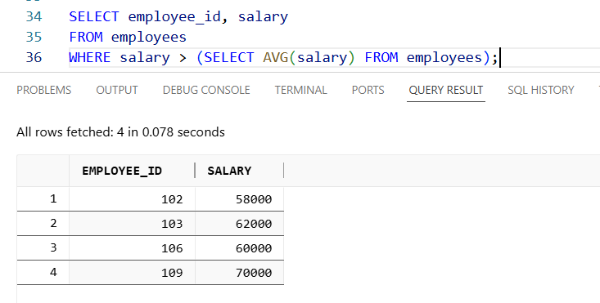

C: This is True. Subqueries can be used in SELECT, FROM, and WHERE clauses.

D: Correlated subqueries execute once per row of the outer query, which can be less efficient than non-correlated subqueries that compute once and reuse results.

Q3.
Answer is

